How to volunteer using the Local Food Coop website

This document describes how to volunteer for upcoming activities, such as collection days, using the Local Food Coop website. You will need to be registered on the Local Food Coop website to volunteer through the website. See the “How to register on the Local Food Coop website” doc for registration instructions, or visit http://localhost/foodcoop/shop and click “Register for account”.

Log in to the website
Go to the green login box on the shop homepage, http://localhost/foodcoop/shop, and enter the email address and password that you registered with. Then press the “Log in to Order” button:

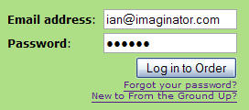

Go to the volunteer rota
After logging in to the website you will see your member homepage, similar to that below. Please ensure you are logged out of Google before continuing – you can do this by clicking on the “click here to log out from Google” link under “Volunteers please read”.
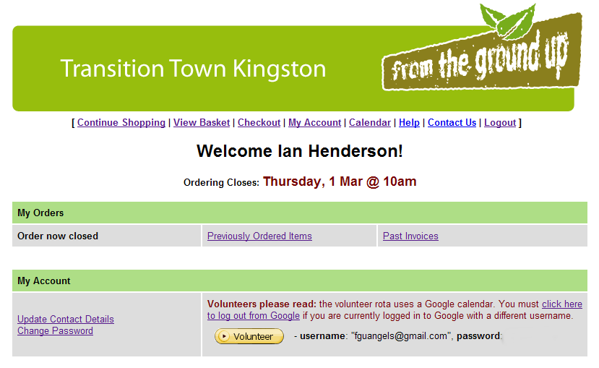
Then note the username (for example, “fguangels@gmail.com”) and password, and click the yellow “Volunteer” button to continue.

Next you will then be asked to enter the username and password, as below. Enter the username (for example, “fguangels@gmail.com”) and password, and click “Sign in” to continue.

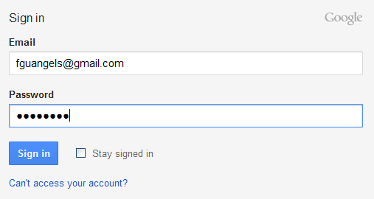

Finally you will be shown the following screen. Click “Allow access” to continue (this gives the website permission to manage the LFC calendar, not any Google calendar that may belong to you).

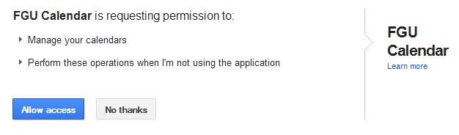

PTO

Sign up for collection days
Tick collections where you would like to volunteer, and untick collections where you can no longer volunteer – see final column below. Once you have selected all your volunteering days, you must click the “Update” button to record your choices. Please wait while the update takes place. You will be sent a confirmation email listing your volunteering dates.

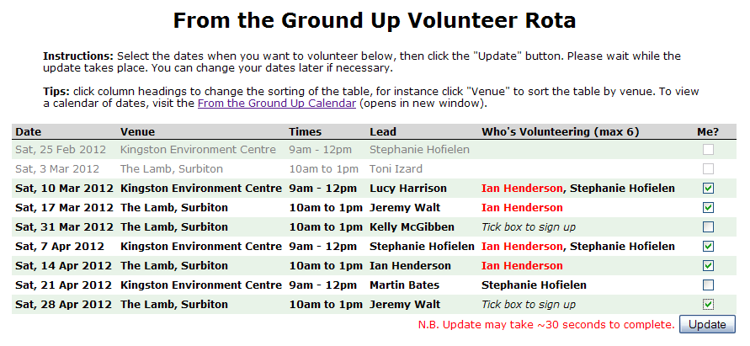
Tip: You can change the order that collections are listed in by clicking the column headings. For instance, to sort the table be venue, click the “Venue” column heading.

Contact volunteers (if needed)
You may want to contact other volunteers, for example if you want to swap dates with someone. Please fill in the form beneath the volunteer rota, choose the group of volunteers to send to, and click “Send Email”:
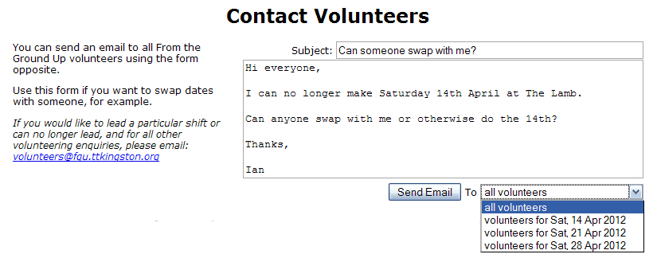
That’s it! Once you send the email, you will receive a copy of the email listing all the recipients and their email addresses. You can revisit the website and add or remove yourself from collection days, or email other volunteers, as many times as you like.

